ISEC 2022
INSTRUCTION FOR ABSTRACTS

Dr Henry Klein
Institute for Thermal Energy Systems
Example Street17, 8010 Graz, Austria
Phone: +43 3112 / 34 5 67
E-Mail: sunshine4u@soon.com

Summary
The summary should not exceed 10 lines, and should include key-words. Text Times New Roman 11

Introduction
This is both a guideline and a template for preparing your abstract. To format your manuscript correctly, please use the fonts and type sizes defined in this document. The manuscript must be uploaded as .pdf file on the ISEC 2022 registration website. https://www.conftool.org/isec2022/(open in September 2021)
The length of the abstract shall be two pages in order to allow getting a good understanding of the topic.
All abstracts are to be submitted by 07 November 2021 (extended deadline). You will receive notification of acceptance in December 2021.

Formatting
The manuscript must be written in English. The abstract title should be written in CAPITAL letters, Arial, 12 points. The section headings should be numbered, in Arial 11 pt bold.
The standard font for the manuscript is Times New Roman for the text and Symbol for special characters. Body text should be justified as block, 11 pt, in single column format.
The paper size is A4 (210 mm x 297 mm). Margins are 20 mm top, 18 mm left and right and 10 mm bottom. Do not insert a page number! References should be made exactly as shown in the example given below.
Number the sections and sub-sections.

Tables
Table 1: Text Times New Roman 10
Graphics | Tables
Graphics | Tables

Equations

Equations should be arranged to the left and should be numbered
(eq. 1)

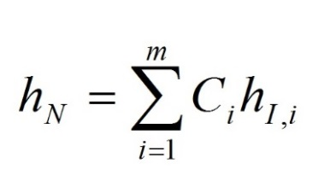

Figures
Figures should be with a resolution of minimum 300 dots per inch and followed by a figure caption.

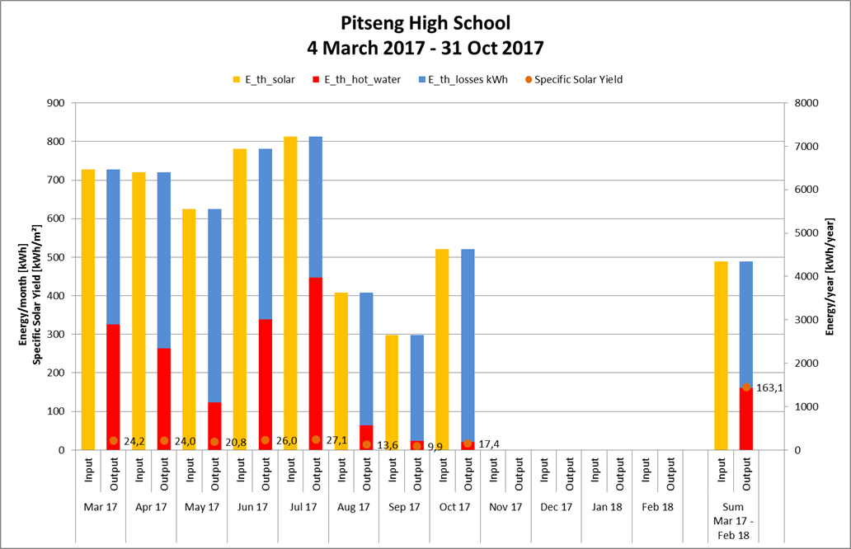
Fig. 1: Table captions (10 pt) should be justified as block and placed below the table

References
Green, C., (2020), Heating Systems for Houses, A Design Handbook. James & James (Sience Publishers) Ltd., London, UK.

Conference Topic
Please indicate here to which of the Conference Topics this abstract refers:

